Project Design Phase-II
Technology Stack (Architecture & Stack)

Date | 12 October 2022
Team ID | PNT2022TMID00966
Project Name | Project – Real time river water quality monitoring and controlling system

Technical Architecture:
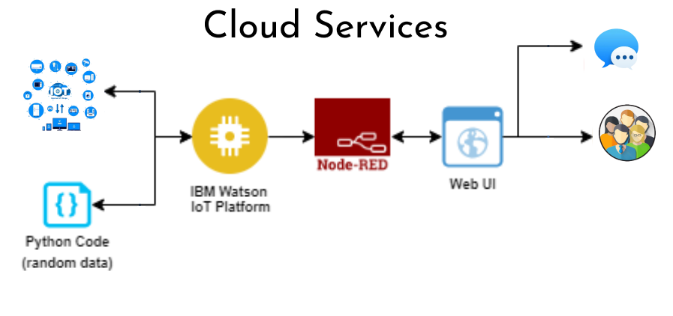

Table-1 : Components & Technologies:
S.No | Component | Description | Technology
 | User Interface | User interacts with the web application through this particular technology | Node Red , MIT app inverter etc.
 | Application Logic-1 | To develop a script for temperature and humidity | Python
 | Application Logic-2 | In order to access the cloud platform | IBM Watson service
 | Application Logic-3 | To build conversational interface with any application and devices | IBM Watson Assistant
 | Cloud Database | To store the data in the cloud service | IBM DB2, IBM Cloudant etc.
 | External API-1 | To monitor the temperature and humidity in the app | IBM Weather API, etc.
 | Infrastructure (Server / Cloud) | Application Deployment on Local System / Cloud  Local Server Configuration:  Cloud Server Configuration : | Local, IBM cloud , etc.

Table-2: Application Characteristics:
S.No | Characteristics | Description | Technology
 | Security Implementations | In order to avoid the third party access to the application . | Encryption ,One time password protection etc
 | Availability | Using of available servers and technology | Cloud servers eg: IBM cloud and services
 | Performance | Different sensors are used to represent multiple performance of the system | Using of sensor eg : pH sensor and turbidity sensor

